We analyzed data from an API call using The Movie Database (TMDB) data. The responses come from IMDB data and some other things that the developers at TMDB created. The project is structured around each heading below.

**What does total distribution of movies released look like per genre?**

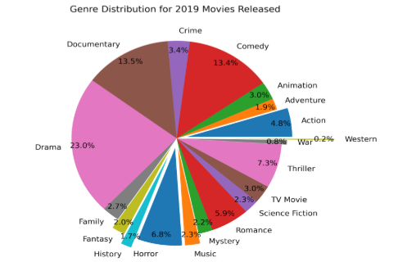

Drama is the most distributed movie type of 2019, with Documentary and Comedy almost tied for 2nd place. This gives us an idea of what movie producers are pushing out to their audiences.

**Which Genre Combinations are most effective?**

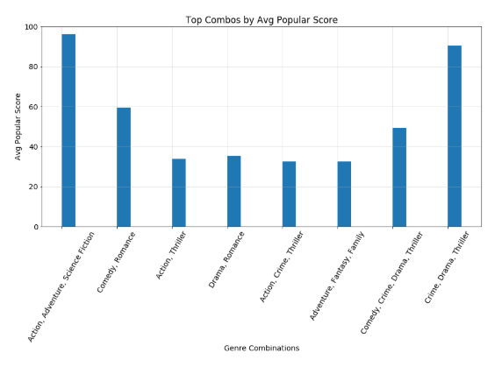

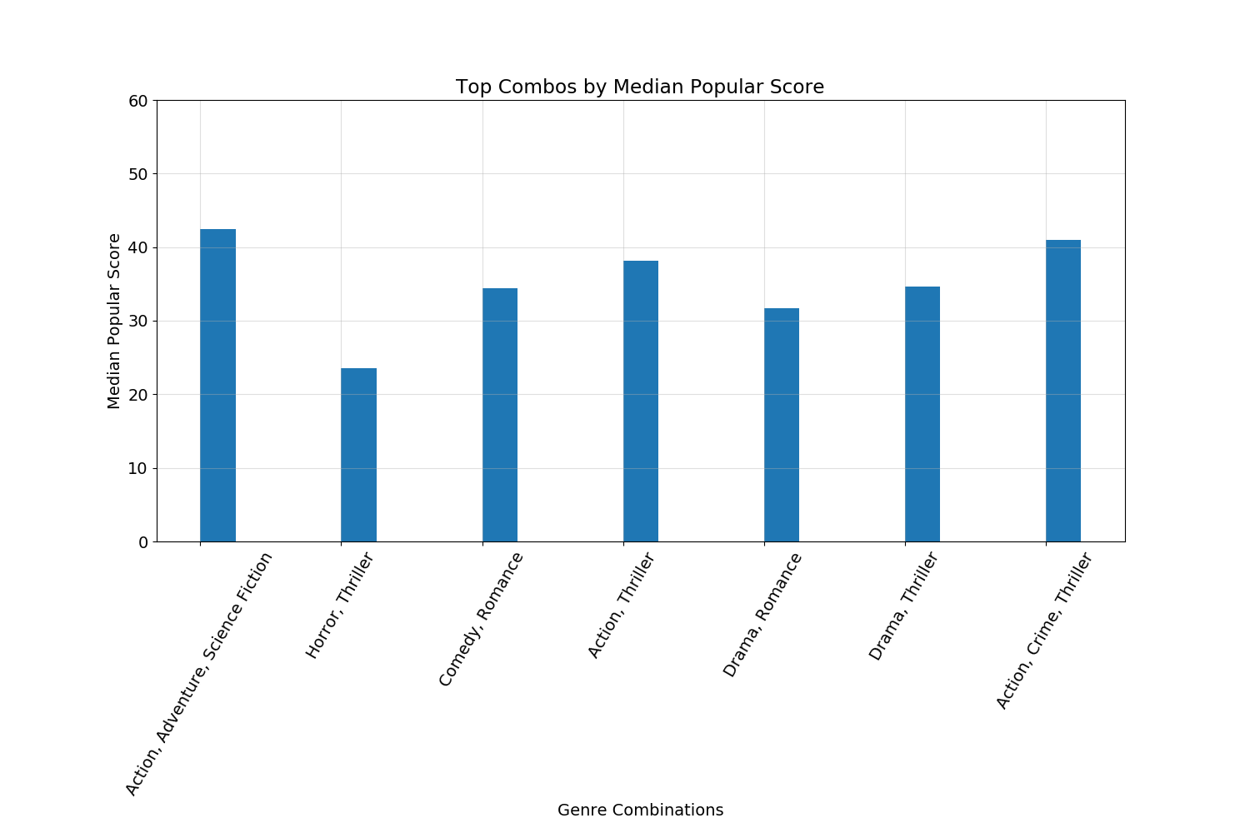

The chart above refers to popular scores, which is a metric that considers number of votes for the day, number of views for the day, number of users who favorited the movie that day, how often it is added to “watchlist”, release date, and previous day’s score. The top performing genre combinations are Action, Adventure, Science Fiction and Crime, Drama, Thriller. According to median scores, the same top 2 combinations are true but have different values.

**Which month had the highest scoring movie? Within that month, what was the genre breakdown in terms of popular score?**

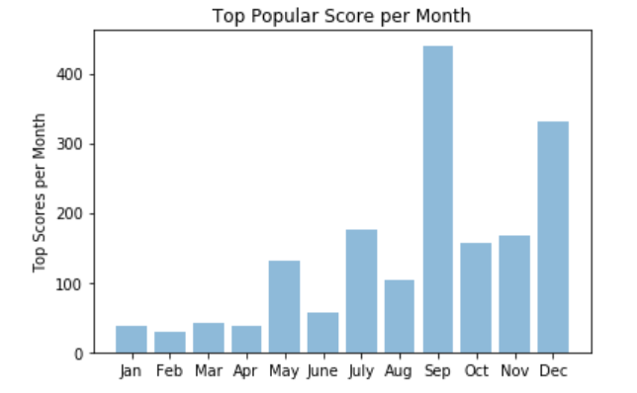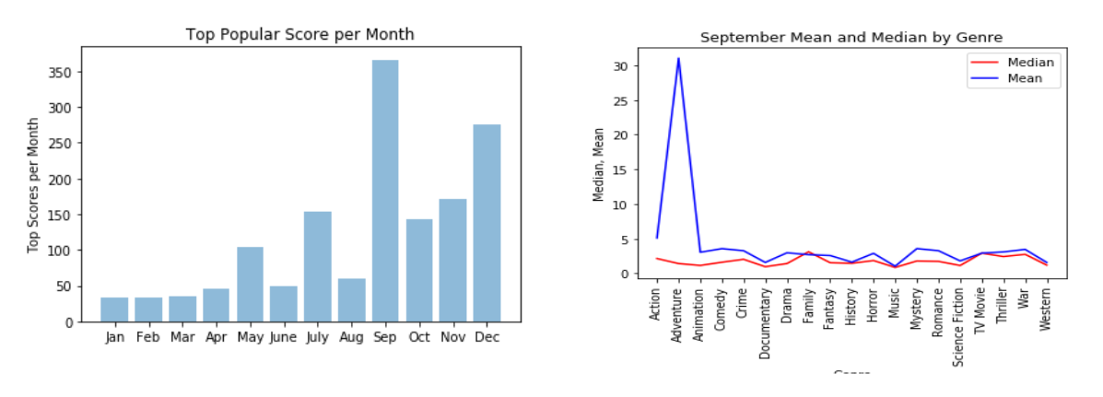

September performed the best on individual popular scores. Within the month of September is a breakdown of all genres for that month and what the median and average scores are. According to the average, the top genre is Adventure, but the highest median score is Family.

The median is the best representation of the September data by genre.

**How did Popular score compare to vote score average?**

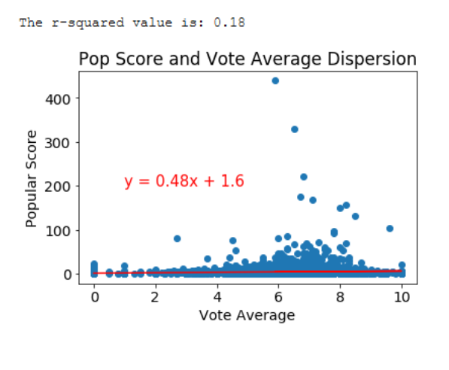

The Vote Average Score comes from IMDB average score, while the popular score combines many other terms. Just because the vote average score went up, doesn’t mean that popular score rises with it. There is not a very strong correlation with vote average score and popular score.

**How did the average Popular Score and Vote Score Average differ over time?**

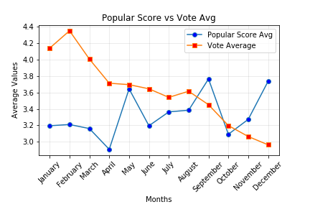

Vote Average held steady for the first 3 quarters of the year and declined in the last quarter of the year, while popular score was more volatile and peaking in December 2019.